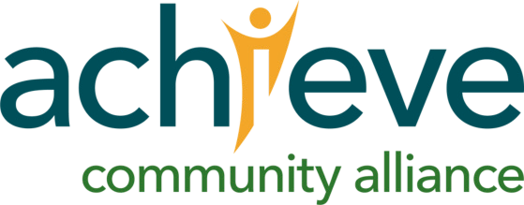

www.achievecommunity.org | P: 501.224.6067 | F: 501.214.5010 | 9720 N. Rodney Parham Road, Little Rock, AR | EIN: 71-0304327 Achieve Community Alliance is an affiliate of United Cerebral Palsy

